AUTOMATED CAR RENTAL MANAGEMENT IN SERVICENOW
Complete Implementation & Visual Verification Documentation
ServiceNow – Service Catalog, Flow Designer, Business Rules, Notifications & Analytics

Project Details
- Project Name: Automated Enterprise Car Rental & Fleet Request Management
- Platform: ServiceNow (Instance: dev428737)
- Application Scope: Car Rental Management (x_1894596_car_re_0)
- Primary Interfaces: Service Portal (/sp) & Classic Workspace
- Deployment Artifact: Car Rental Management.xml

1. Business Rule Exception Handling & Incident Generation
Navigation: All > Incidents > Filter: Short description contains "Car unavailable"
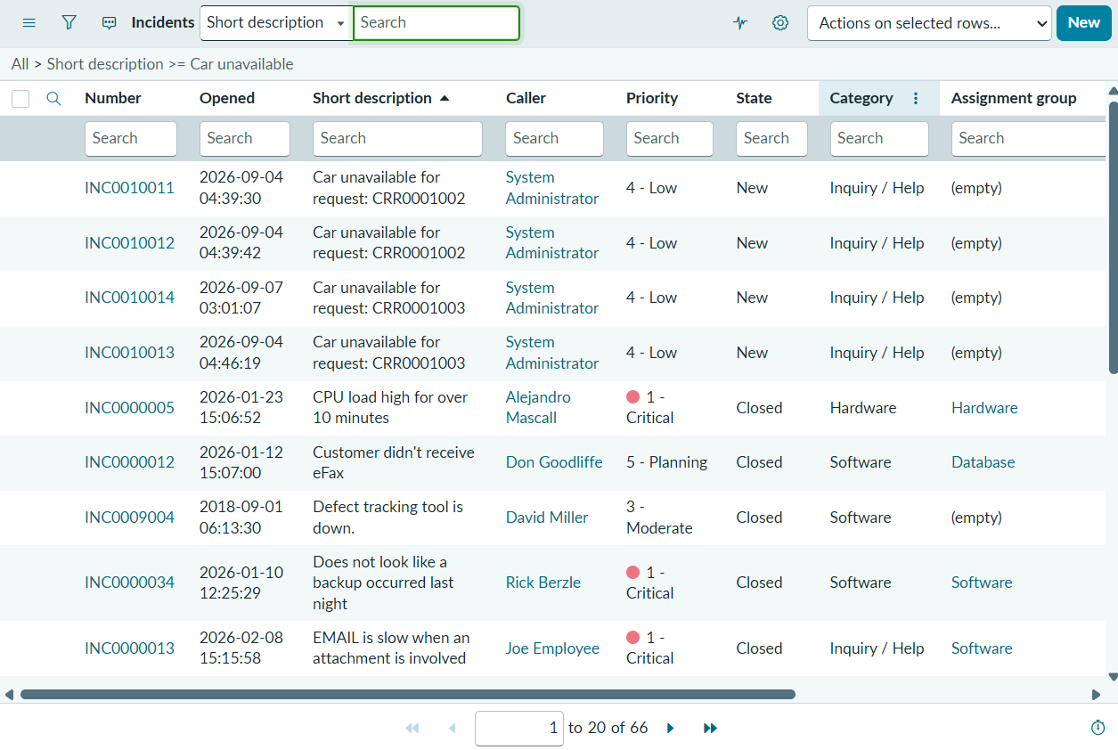
: 01_Incident_Auto_Creation.png ]
Figure 1.1: Automated creation of incidents INC0010011 through INC0010014 by After Business Rule when car rental requests are marked unavailable or rejected.

2. Service Catalog Request & Task Fulfillment
Navigation: All > sc_req_item.list > RITM0010001
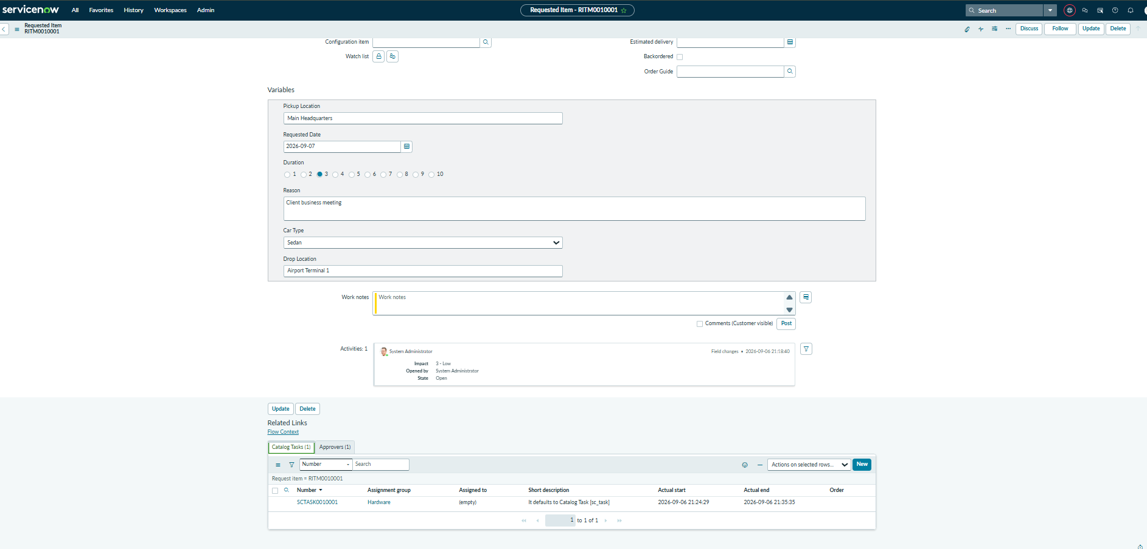: 02_RITM_and_Task_Fulfillment.png ]
Figure 2.1: Requested Item (RITM0010001) record capturing trip variables (Main Headquarters, Sedan, etc.) and linked fulfillment task SCTASK0010001.

3. Workflow Studio / Flow Designer Automation Execution
Navigation: All > Workflow Studio > Flows > Car Rental Req > Execution Details
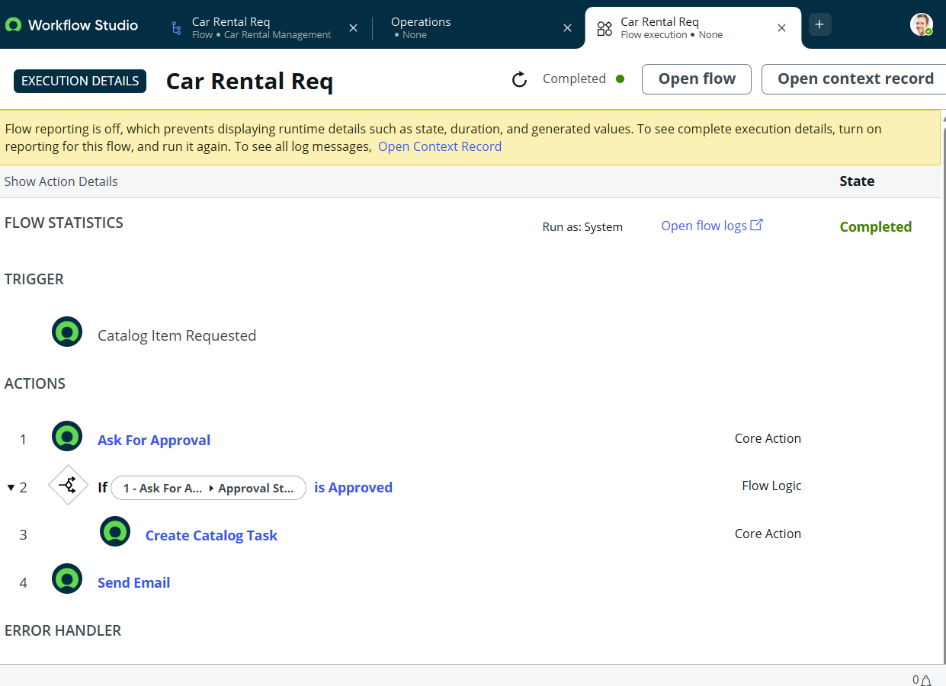: 03_Flow_Execution_Trace.png ]
Figure 3.1: Flow Designer execution report confirming completion of Trigger, Manager Approval check, Catalog Task creation, and Notification dispatch.

4. System Notification & Email Dispatch Log
Navigation: All > System Logs > Emails (sys_email.list)
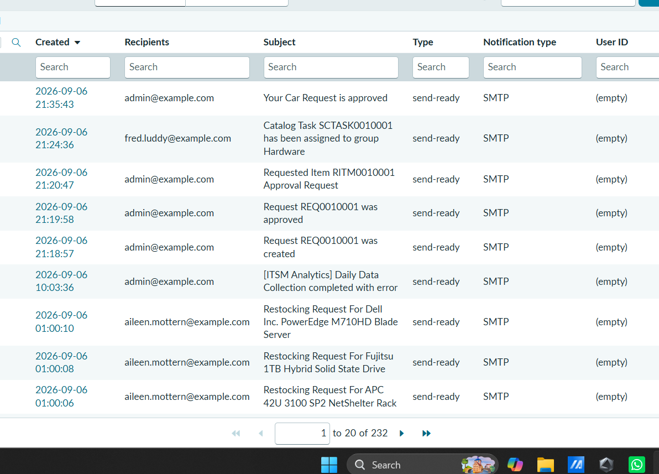: 04_Email_Notification_Log.png ]
Figure 4.1: ServiceNow system email log displaying the approved reservation notification "Your Car Request is approved" in send-ready status.

5. Deployment Packaging & Local Update Set
Navigation: All > System Update Sets > Local Update Sets
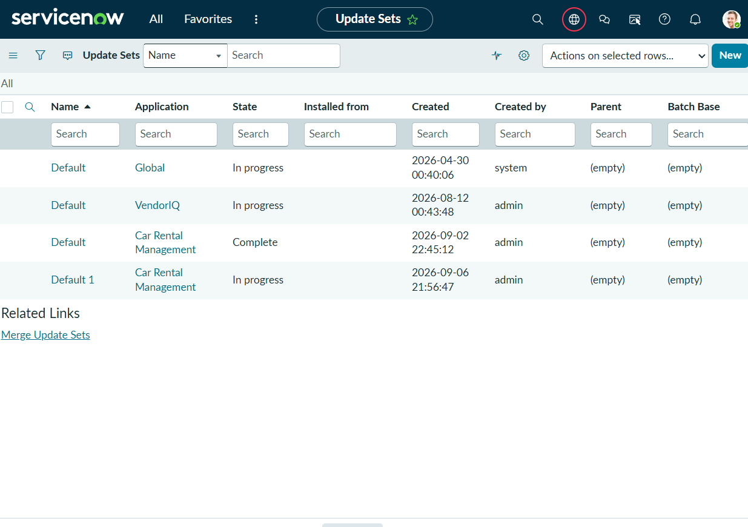 05_Update_Set_Complete.png ]
Figure 5.1: Local Update Set "Car Rental Management" verified in State: Complete, sealing all custom tables, flow logic, forms, and business rules for export.

6. Platform Analytics Fleet Dashboard
Navigation: All > Platform Analytics > Dashboards > Car Rental Management Dashboard
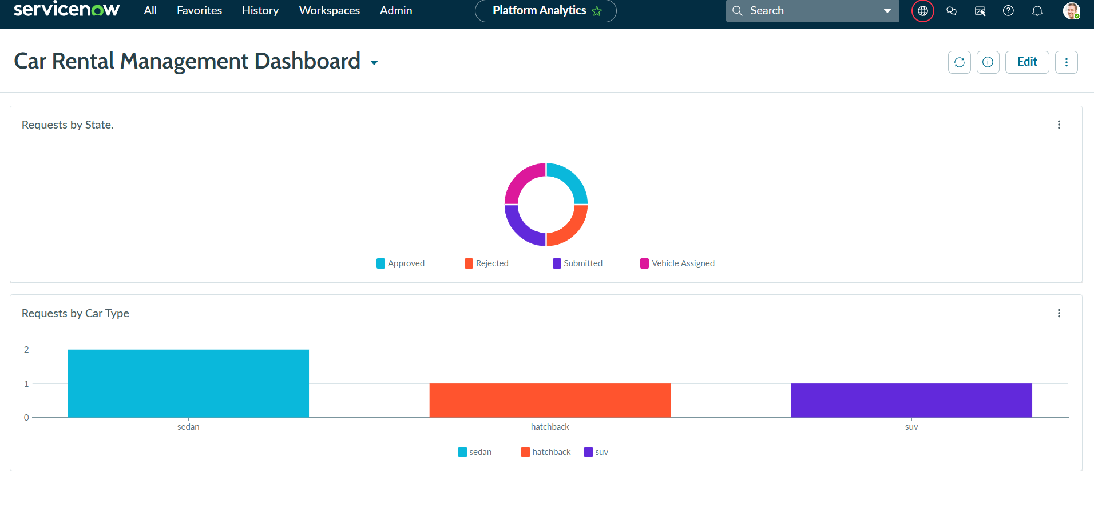: 06_Dashboard_Analytics.png ]
Figure 6.1: Active Car Rental Management Dashboard visualizing real-time metrics for Requests by State (Donut Chart) and Requests by Car Type (Bar Chart).

